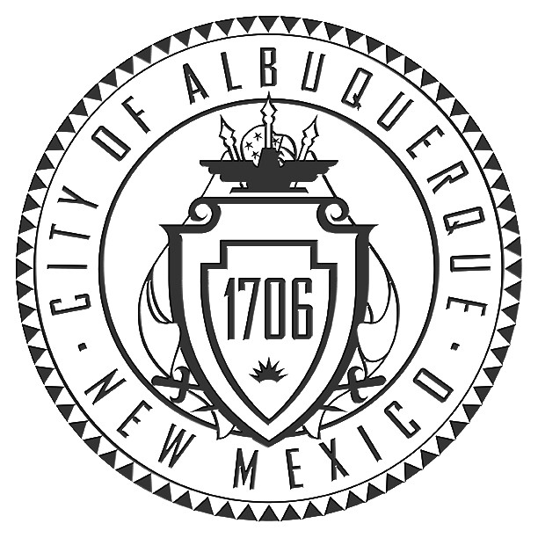
Office of the City Clerk

P.O. Box 1293
Albuquerque, NM 87103
Phone (505) 768-3030 Fax (505) 768-2845

Amy B. Bailey, City Clerk

BOARD OF ETHICS
&
CAMPAIGN PRACTICES
CITY/COUNTY GOVERNMENT CENTER

CITY COUNCIL CHAMBERS, BASEMENT LEVEL

ROBERT P. TINNIN JR., Chairman
Kay Duffin
Herb H. Hughes
Cliff Richardson
Benjamin Silva
Jimmy Trujillo
Jolene Wolfley

Amy B. Bailey, City Clerk
Helen Elliott, Campaign Auditor

AGENDA

Friday, August 12, 2011
4:00 p.m.

Item 1. Call to Order

Item 2. Candidates and Treasurers Orientation

Item 3. Measure Finance Committees Orientation

Item 4. Adjourn

